**Coding Academy By Orange**

**JAN 12th 2020**



**YOUR LOGO**

**TRAINEE FUTURE**

**RAGHAD AL-ADWAN**

**Version 1.0**

Table of Contents

**1.** **INTRODUCTION**

**1.1** **PURPOSE** **1**

**1.2** **INTENDED AUDIENCE AND PERTINENT SECTIONS** **1**

**1.3** **PROJECT SCOPE** **1**

**1.4** **REFERENCES** **1**

**2.** **DESCRIPTION** **2**

**2.1** **PRODUCT PERSPECTIVE** **2**

**2.2** **FEATURES** **2**

**2.3** **USER OVERVIEW** **2**

**2.4** **OPERATING ENVIRONMENT** **2**

**2.5** **ASSUMPTIONS** **2**

**3.** **SYSTEM FEATURES 3**

**3.1 SYSTEM** **FEATURE 1 3**

**3.2** **SYSTEM FEATURE 2 3**

**4.** **REQUIREMENTS OF EXTERNAL INTERFACE** **4**

**4.1** **USER INTERFACES** **4**

**4.2 System Design 4**

**4.2.1 Use Case Diagram 4**

**4.2.2 Class Model 4**

**4.3** **HARDWARE INTERFACES**  **4**

**4.4** **SOFTWARE INTERFACES** **4**

**4.5** **COMMUNICATION INTERFACES** **4**

**5.** **ADDITIONAL NONFUNCTIONAL REQUIREMENTS** **5**

**5.1** **PERFORMANCE****5**

**2.2 Usability 5**

**2.3 Reliability 5**

**6.** **SOFTWARE QUALITY** **6**

**6.1 Availability 6**

**6.2 Interoperability 6**

**6.3 Maintainability 6**

**Abstract**

E-recruitment allows for immediate real-time interaction and 24x7 hiring or vacancy search activity. Employers can post a vacancy in as little as 20 minutes on a career with no limits to ad size and start receiving Requests in response immediately.

this website is tries to help a user who is looking for trainee opportune . try to make one place where students and job seeker can meet .

In order to help the users such as trainee to determine their best career choice. Furthermore, users such as company can post a vacancy description, when they look for trainee.

Mainly this application has been designed using (MongoDB, ExpressJS, ReactJS, NodeJS) MERN Stack as web development framework.

# INTRODUCTION

## 1.1 PURPOSE

Web application that allow companies to find all trainee requests in one place in different fields without need to view a lot of emails, also trainee can find similar training opportunity in different companies.

## 1.2 INTENDED AUDIENCE AND PERTINENT SECTIONS

Stakeholders are :

* Universities.
* Companies : who can share about vacancies easily
* University students: who can find the trainee opportunity
* ministry of Higher Education & Scientific Research: who can manage the process of training between the company and trainee

## 1.3 PROJECT SCOPE

1.For Companies, can post vacancies in different field wither for training or employment.

2.Companies post for vacancies more specific in same field.

3.Trainee can find more than one opportunity in different companies for University Training in his field

4.Help trainee to know more about Companies that work in the same interest’s field.

**1.4 DOCUMENT CONVENTIONS**

* MERN Stack: MongoDB, ExpressJS, Reactjs, and NodeJS.
* CRUD operations:
  + Create(Add New Record To Database)
  + Read (Read Data from database)
  + Update(Edit Record on database)
  + Delete(remove record from database).
* HTTP:Hyper Text Transfer Protocol

## 1.4 REFERENCES

**ReactJS:** v7.5.5, 2019, react documentation,

[**https://reactjs.org/docs/getting-started.html**](https://reactjs.org/docs/getting-started.html)

**MongoDB:** v5.7.14 ,2019, mongoDB Documentation ,

[**https://docs.mongodb.com/**](https://docs.mongodb.com/)

**ExpressJS:** v4.17.1 , 2019 express documentation ,

[**https://devdocs.io/express/**](https://devdocs.io/express/)

**NodeJS:** v12.14.0 ,2019 nodejs documentation ,

[**https://nodejs.org/en/docs/**](https://nodejs.org/en/docs/)

**Bootstrap:** v4 , 2019 Bootstrap

[**https://getbootstrap.com/**](https://getbootstrap.com/)

**Npm:** 2019 , react-npm ,

[**https://www.npmjs.com/**](https://www.npmjs.com/)

# DESCRIPTION

## 2.1 FEATURES

1.User can register as company or trainee.

2.User can Login as Company or Trainee.

3.Companies can view his profile or edit his information’s

4.Companies can add Post’s that contains Description, field’s and date about open vacancy.

5.Companies can edit, update or delete post.

6.Company can View trainees profile information’s.

7.Company can Accept or Reject Trainee Request.

8.Trainee can view his profile or edit his information’s.

9.Trainee can send Request for a vacancy compatible with his Field.

10.Trainee can send many requested for many companies.

11.Trainee can find out the approval company his request or not.

## 2.2 USER OVERVIEW

Web application that allow companies to find all trainee requests in one place in different fields without need to view a lot of emails, also trainee can find similar training opportunity in different companies

## 2.3 OPERATING ENVIRONMENT

* NodeJS.
* React 16.12.0
* Express 4.17.1
* NPM
* axios 0.19.0
* bcryptjs 2.4.3
* body-parser 1.19.0
* bootstrap 4.4.1
* concurrently 5.0.1
* firebase 7.6.0
* mongoose 5.8.1
* passport 0.4.1
* react-bootstrap 1.0.0-beta.16
* react-cookie 4.0.1
* react-dom 16.12.0
* react-router-dom 5.1.2
* react-scripts 3.3.0
* validator 12.1.0
* cors 2.8.5

## 2.5 ASSUMPTIONS

* The user will get all the resources that he need.
* Trainee can find good opportunity during the semester.
* All relevant stakeholders will keep up to date with each other.

# SYSTEM FEATURES

## 3.1 SYSTEM FEATURE 1

|  |  |
| --- | --- |
| **DESCRIPTION AND PRIORITY** | High priority  Companies share own internship vacancies |
| **STIMULUS / RESPONSE SEQUENCES** | * Register * Login * Add posts contains   + vacancy field   + Date   + training requirement * view all requests from trainees * Acceptance or rejection trainee requests |
| **FUNCTIONAL REQUIREMENTS** | can't get any results if there is no posts. |

## 3.2 SYSTEM FEATURE 2

|  |  |
| --- | --- |
| **DESCRIPTION AND PRIORITY** | High priority   Trainees can find all posts of their interested field |
| **STIMULUS / RESPONSE SEQUENCES** | * Register * Login * View all posts * send request to the companies posts * wait companies to accept or reject the request |
| **FUNCTIONAL REQUIREMENTS** | can’t get any results if user did not send any request. |

# REQUIREMENTS OF EXTERNAL INTERFACE

## 4.1 USER INTERFACES

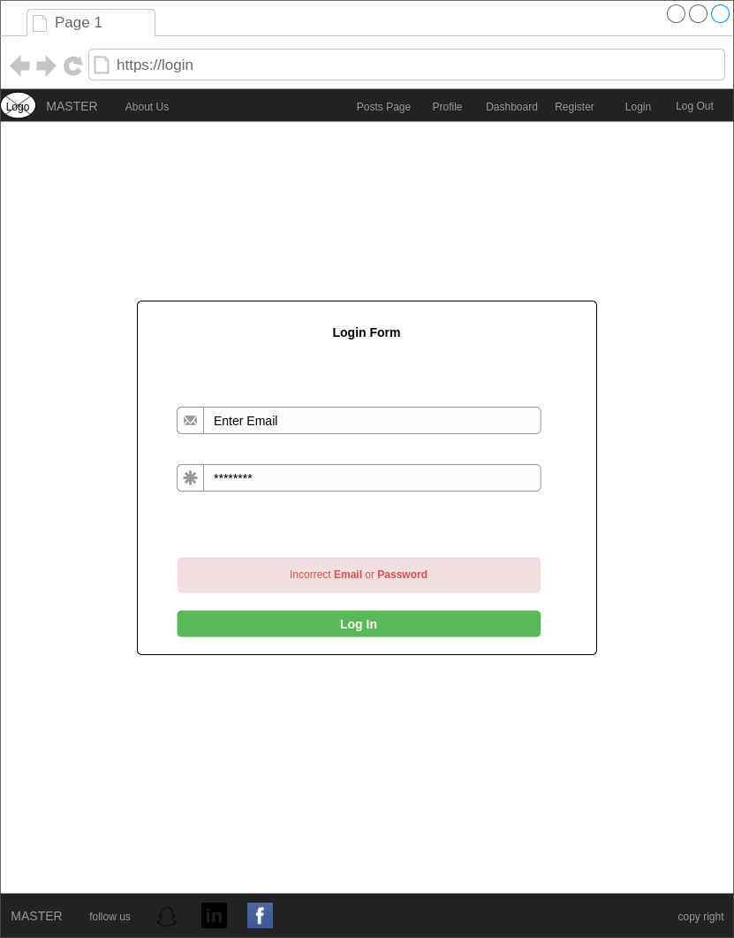

**Login page**

contains two field for Email and password.

The user must enter his e-mail and

password and then click on Login.



**Register Page**

* Company Register page

It contains nine field

* Company Name
* Company Email
* password
* website
* Location
* Company Description
* Image
* Register Button

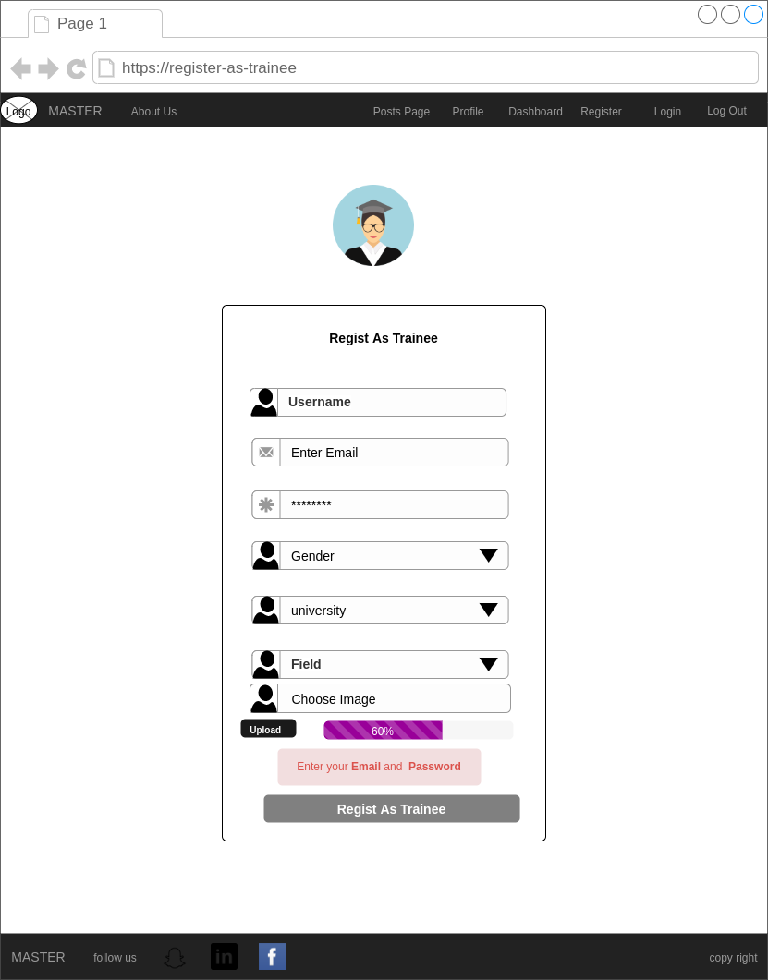

**Register Page**

* Trainee Register page

It contains nine field

* Trainee Name
* Trainee Email
* password
* Gender
* University
* Field
* Image
* Register Button

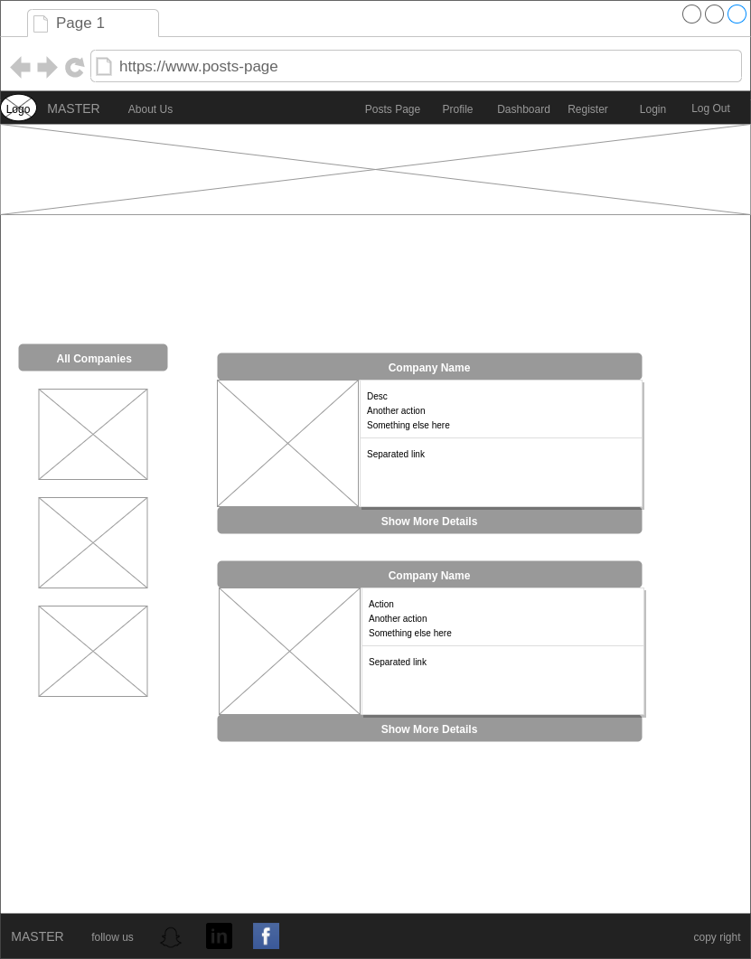

**Posts Page**

All posts will appear in this page depends on user role condition

* Company: show all posts related to it.
* Trainee : show all posts related to the

study field of trainee

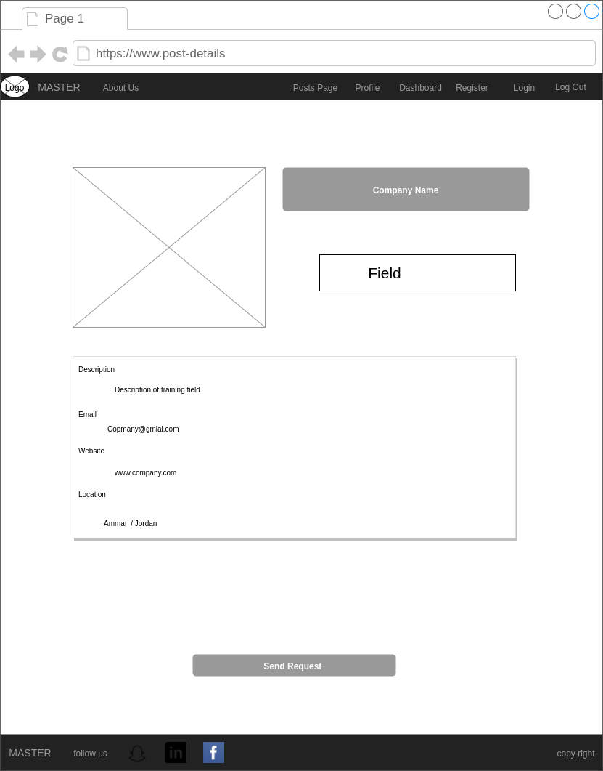

**Post Details**

It contains:

* Company Image
* field
* Description of the vacancy
* Company Email
* Company website
* Company Location
* Send request button

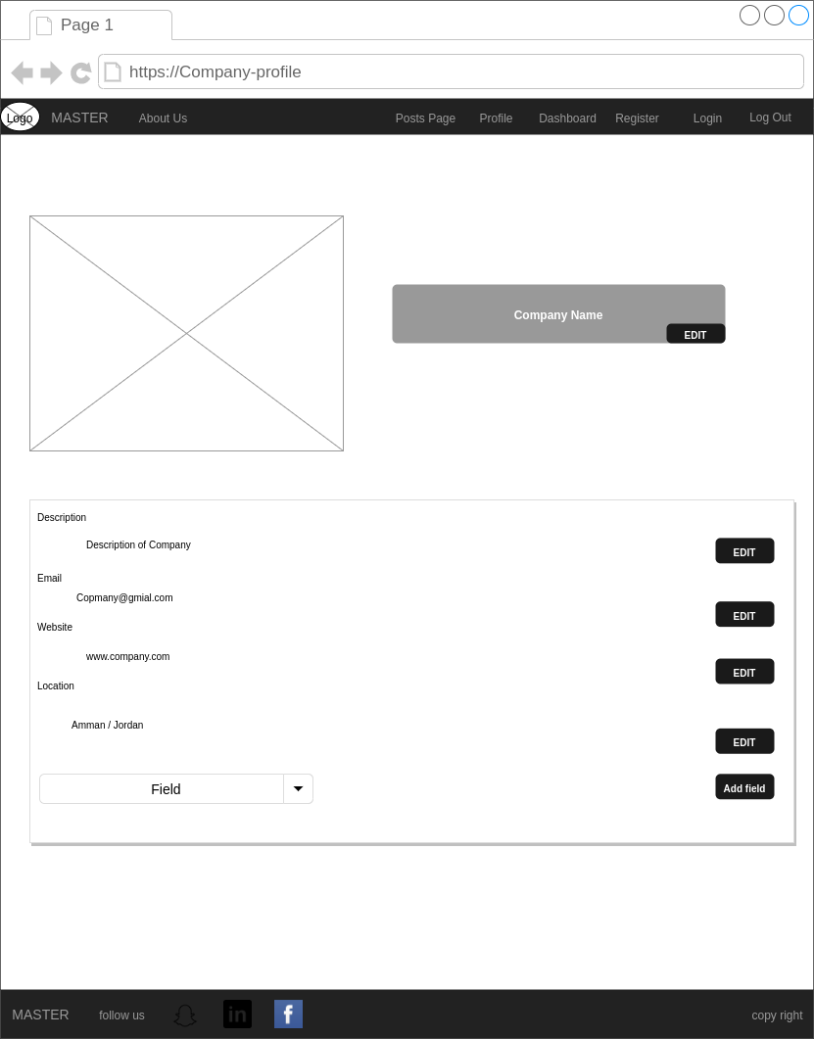

**Company Profile**

It contains :

* Image
* Name
* Description
* Email
* Location
* Website
* Field

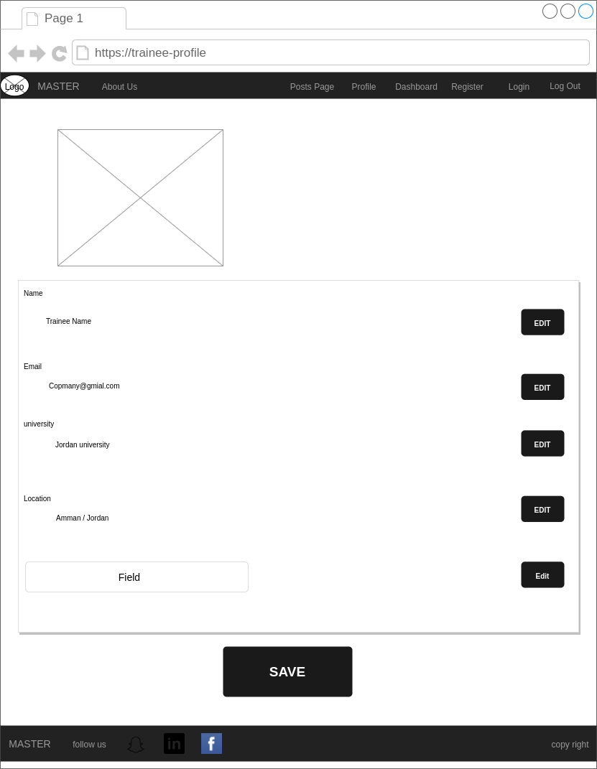

**Trainee Profile**

It contains :

* Image
* Name
* Email
* University
* Field

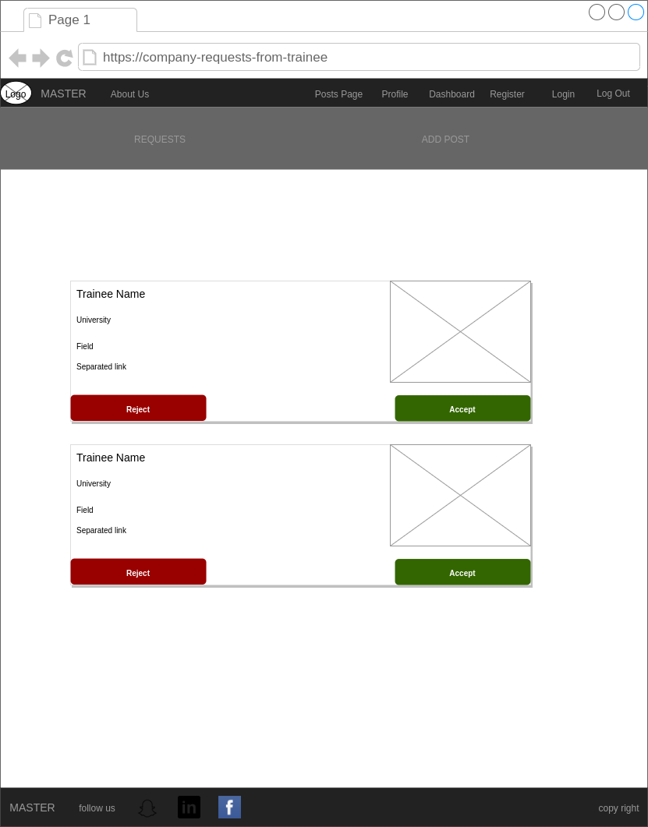

**Company Dashboard**

contains trainees request

* Trainees Image
* Trainees name
* Trainees Field
* Trainees universities
* Accept button
* Reject button

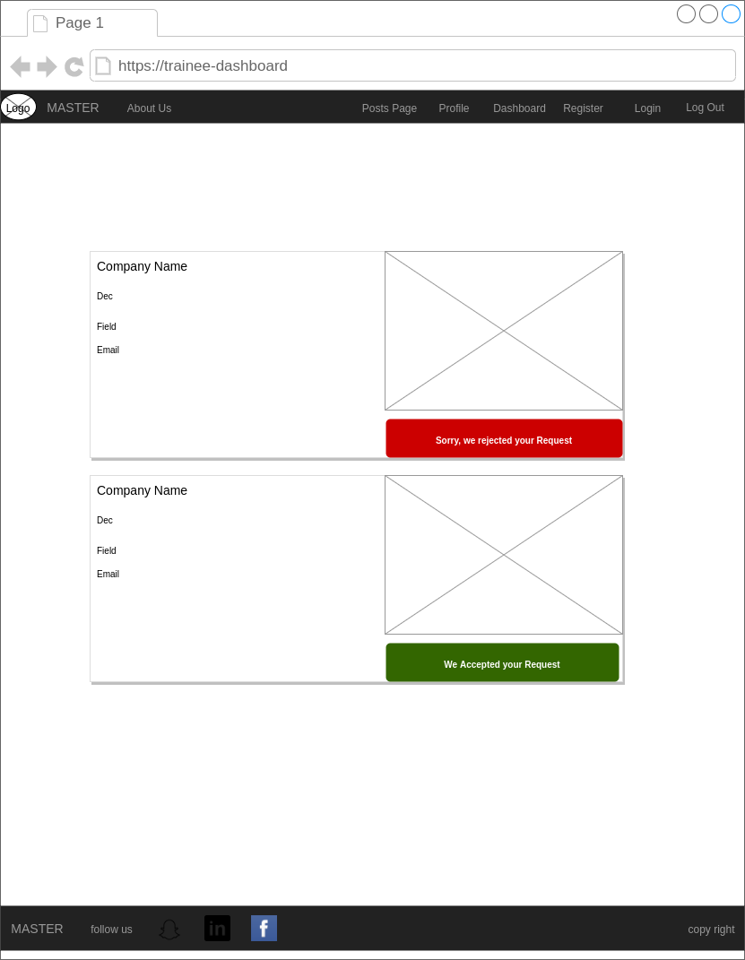

**Trainees Dashboard**

contains acceptance or rejection requested

* Companies Image
* Companies name
* Companies Field
* Companies Email
* Acceptance alert
* Rejection alert

**4.2 System Design**

The system design process partitions the requirements to hardware or software system. Software design involves identifying the fundamental software system abstractions and their relationships.

## Use Case Diagram

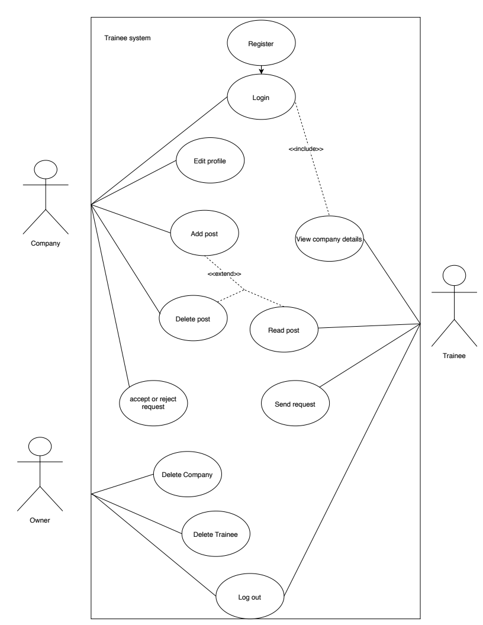

## Database Design

## 

## 4.3 HARDWARE INTERFACES

* Any device which has a web browser

## 4.4 SOFTWARE INTERFACES

* Axios
* Bootstrap
* NodeJS
* Express
* MongoDB

## 4.5 COMMUNICATION INTERFACES

* HTTP protocols

# 5. ADDITIONAL NONFUNCTIONAL REQUIREMENTS

* **Performance:** Include of response time and concurrency level of project.
* **Usability:** This application is easy to use by every user.
* **Reliability:** Accuracy of results and the system meets requirements and depends on the deployment of system.

**6. Software Quality**

* **Availability :** The web will be available as long as server is up**.**
* **Interoperability :** Web is interoperable on various operating system, thus increasing the applications usability and flexibility.
* **Maintainability:** Every working step was documented in the project so we can change anything in case we needed to change.